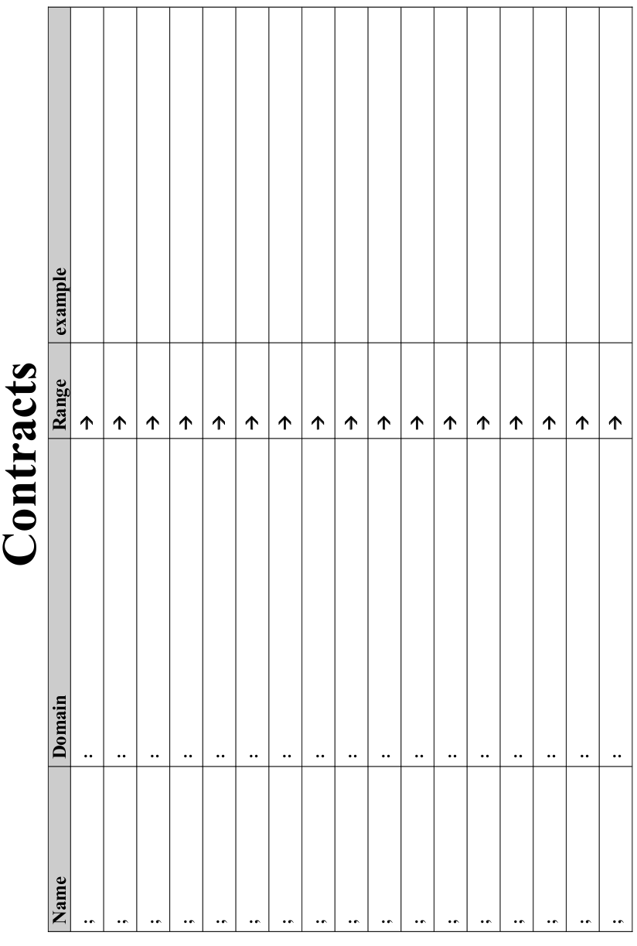

Lesson 1

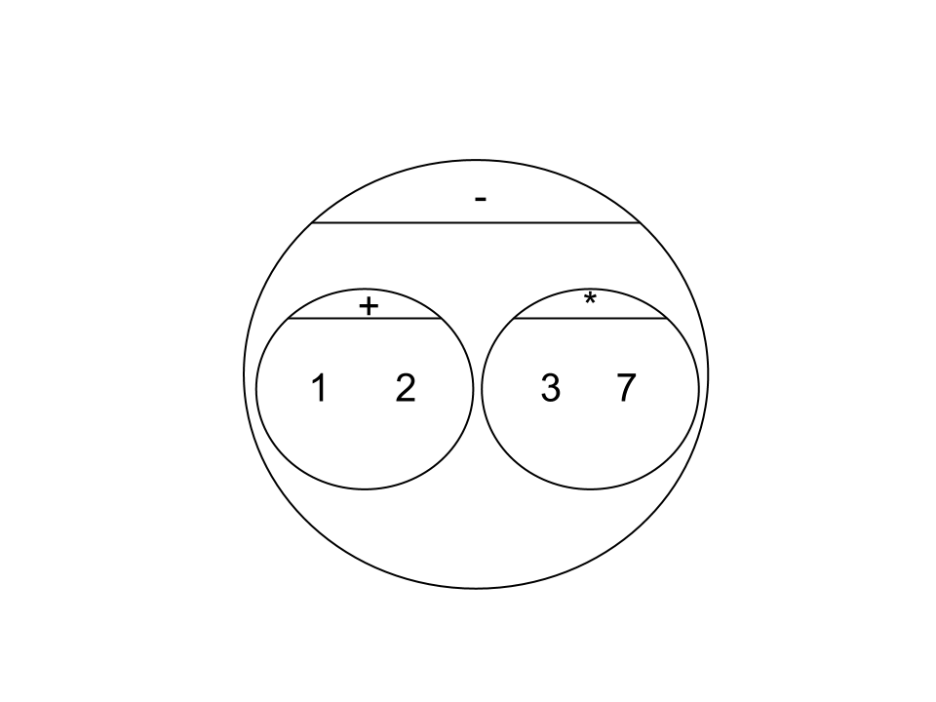
Circles Competition Time: 5 minutes
 | Math | Circle of Evaluation | Scheme Code
Round 1 | 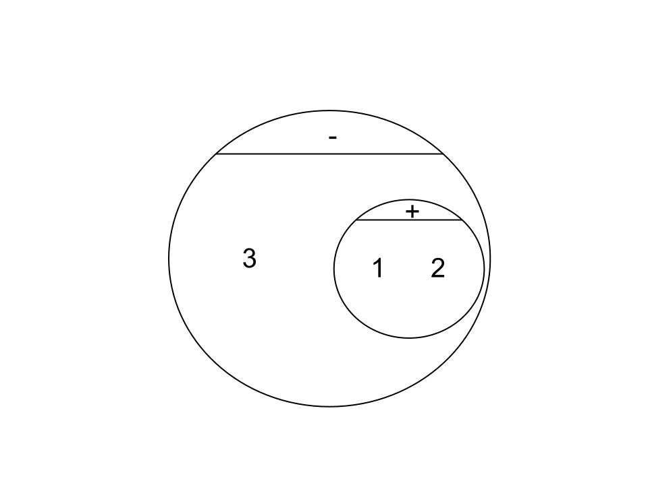  (1 + 2) - (3 * 7) |  | (- (+ 1 2) (* 3 7))
Round 2 | 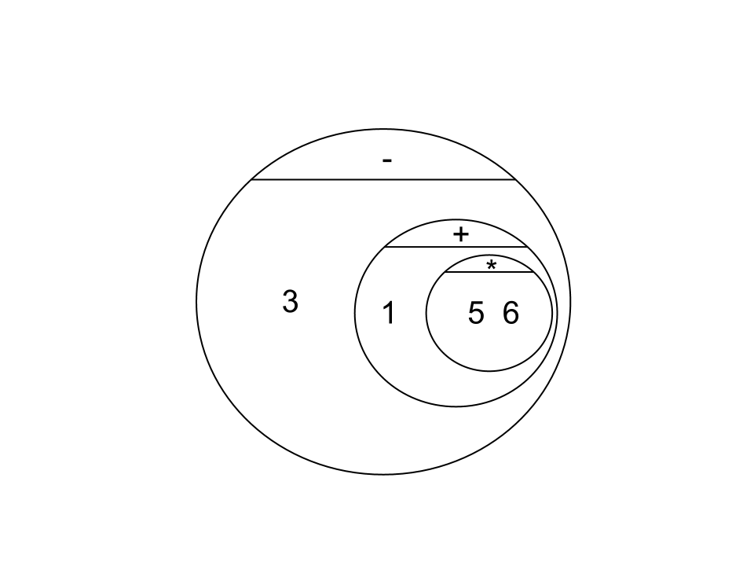  3 - (1 + 2) |  | (- 3 (+ 1 2))
Round 3 | 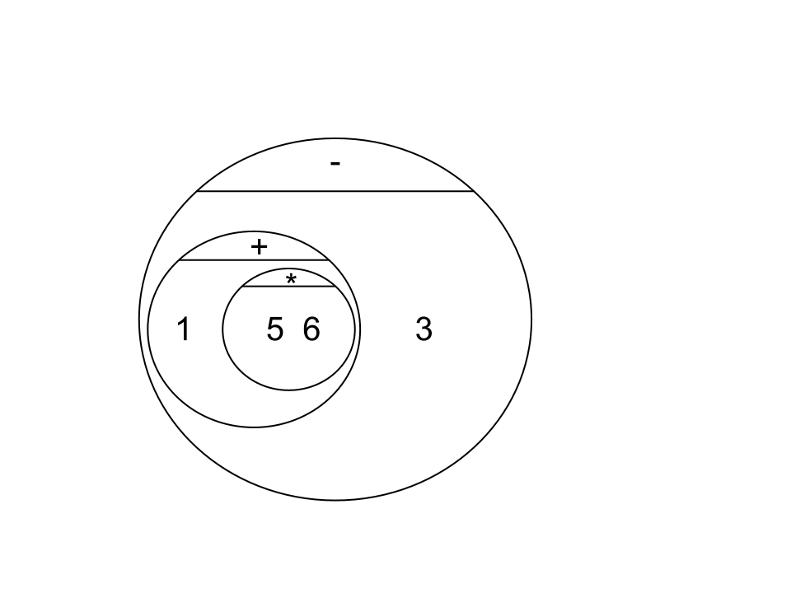  3 - (1 + (5 * 6)) |  | (- 3 (+ 1 (* 5 6)))
Round 4 | (1 + (5 * 6)) - 3 |  | (- (+ 1 (* 5 6)) 3)


Fast Functions!
Fill out the contract for each function, then try to write two examples and the definition by yourself.
; _double____________:__Number________ -> _Number________
name domain range
(EXAMPLE (_double_ __5__) _( * 2 5 )_____________)
(EXAMPLE (_double_ __7__) _( * 2 7 )_____________)
(define (__double_ _n____) _( * 2 n )________________)
; _triple_________ : __#____________ -> __#______________
name domain range
(EXAMPLE (triple_ 7____) __(* 3 7)______________)
(EXAMPLE (triple_ 9____) __(* 3 9)______________)
(define (_triple_ _n__) ___(* 3 n)________________)
; __plus1__________:__#______________ -> ___#_____________
(EXAMPLE (plus1__ _4_____) _(+ 1 4 ) ___________________)
(EXAMPLE ( plus1 __13______) (+ 1 13 ) ____________________)
(define (_plus1_ __n_____) _(+ 1 n) ___________________)
; __mystery_______:___#______________ -> ___#_____________
(EXAMPLE (_mystery_ _5_) _(- 7 4 )_______________)
(EXAMPLE (_mystery_ _8_) _(- 7 8 )_______________)
(define (_mystery_ _x_) _(- 7 x)_______________)

Lesson 2

Design Recipe: SAMPLE

State the problem:

Make a circle (spot) of size 100, with the provided color

Contract+Purpose Statement
Every contract has three parts:

; ___spot100____ : String -> Image
name Domain Range

; Makes a size 100 circle in a color What does the function do?

Give Examples

On the computer, write an example of your function in action, using EXAMPLE.

(EXAMPLE ( spot100 “green” )(circle 100 “solid” “green” ))
the user types… ...which should become
color

(EXAMPLE ( spot100 “blue” )(circle 100 “solid” “blue” ))
the user types… ...which should become

Function
Circle the changes in the EXAMPLEs, and name the variables.
Write the code, copying everything that isn't circled, and using names where you find variables!

(define (spot100 color ) (circle 100 “solid” color ))
function name variable names ...and the computer does this

Design Recipe: double-radius

State the problem:
Write a function, double-radius, which takes in a radius and color, and makes an outline circle of the same color, but double the size

Contract+Purpose Statement
Every contract has three parts:

; __double-radius________ : __Number String______ -> __Image_________
name Domain Range

; Doubles the radius, and draws a circle of that new size and color
What does the function do?

Give Examples
On the computer, write an example of your function in action, using EXAMPLE.
EXAMPLE (double-radius 6 “blue”) (circle (* 2 6) “outline” “blue”) )
the user types… ...which should become

(EXAMPLE (double-radius 10 “red”) (circle (* 2 10) “outline” “red”) )
the user types… ...which should become

Function
Circle the changes in the EXAMPLEs, and name the variables.
Write the code, copying everything that isn't circled, and using names where you find variables!

(define (double-radius radius color) (circle (* 2 radius) “outline” color) )

Design Recipe: double-width

State the problem:
Write a function, double-width, which takes in a height and a color, and makes a solid rectangle, where the width is twice the height

Contract+Purpose Statement
Every contract has three parts:

; __double-width__ : __Number String___________ -> __Image__
name Domain Range

; draws a rectangle where the width is twice the height, of the given color
What does the function do?

Give Examples
On the computer, write an example of your function in action, using EXAMPLE.

(EXAMPLE (double-width 3 “green”) (rectangle 3 (* 2 3) “solid” “green”))
the user types… ...which should become

(EXAMPLE (double-width 7 “yellow”) (rectangle 7 (* 2 7) “solid” “yellow”))
the user types… ...which should become

Function
Circle the changes in the EXAMPLEs, and name the variables.
Write the code, copying everything that isn't circled, and using names where you find variables!

(define (double-width h color) (rectangle h (* 2 h) “solid” color))

Design Recipe: paint-job

State the problem:
Write a function called paint-job that takes an auto and changes its color

Contract+Purpose Statement
; _paint-job_______ : __auto string____________________ -> __auto__________
name Domain Range
; takes in an auto and a color, and returns an auto with that color
What does the function do?

Give Examples
(EXAMPLE (_paint-job____ ___car1 “green”___________________)
(make-auto (auto-model car1)_______________________
____________(auto-hp car1)_______________________
____________(auto-rims car1)_______________________
____________”green”_______________________
____________(auto-value car1)___________)____________)
(EXAMPLE (_paint-job____ ___car2 “black”___________________)
(make-auto (auto-model car2)_______________________
____________(auto-hp car2)_______________________
____________(auto-rims car2)_______________________
____________”black”_______________________
____________(auto-value car2)___________)____________)

Function
(define (_paint-job____ ___auto color___________________)
(make-auto (auto-model auto)_______________________
____________(auto-hp auto)_______________________
____________(auto-rims auto)_______________________
____________color_______________________
____________(auto-value auto)___________)____________)

Design Recipe: turbo-charge

State the problem:
Write a function called turbo-charge that takes an auto and adds 20 hp

Contract+Purpose Statement
; _turbo-charge______ : _auto___________________________ -> __auto________
name Domain Range
; takes in an auto and returns the same auto, with twenty more hp_____________
What does the function do?

Give Examples
(EXAMPLE (_turbo-charge___ __car1_____________________________)
(make-auto _(auto-model car1)___________________________
_(+ 20 (auto-hp car1))___________________________
_(auto-rims car1)___________________________
_(auto-color car1)___________________________
_(auto-value car1) )___________________________)
(EXAMPLE (_turbo-charge___ __car2_____________________________)
(make-auto _(auto-model car2)___________________________
_(+ 20 (auto-hp car2))___________________________
_(auto-rims car2)___________________________
_(auto-color car2)___________________________
_(auto-value car2) )___________________________)

Function
(define (_turbo-charge___ __auto_____________________________)
(make-auto _(auto-model auto)___________________________
_(+ 20 (auto-hp auto))___________________________
_(auto-rims auto)___________________________
_(auto-color auto)___________________________
_(auto-value auto) )___________________________)

Lesson 3

Design Recipe: pimp

State the problem:
+100 hp, red, +10000 value, 30” rims

Contract+Purpose Statement
; ___pimp_________ : __auto________________________________ -> __auto____________
name Domain Range
; takes in an auto and makes it red, 30” rims, +100 hp and +10000 value
What does the function do?

Give Examples
(EXAMPLE (__pimp______ __car1________________________________)
_(make-auto (auto-model car1)________________________
____________(+ 100 (auto-hp car1))____________________
____________30_____________________________________
____________”red”___________________________________
____________(+ 10000 (auto-value car1)))_______________)
(EXAMPLE (__pimp______ __car2________________________________)
_(make-auto (auto-model car2)________________________
____________(+ 100 (auto-hp car2))____________________
____________30_____________________________________
____________”red”___________________________________
____________(+ 10000 (auto-value car2)))_______________)

Function
(define (__pimp______ __auto________________________________)
_(make-auto (auto-model auto)________________________
____________(+ 100 (auto-hp auto))____________________
____________30_____________________________________
____________”red”___________________________________
____________(+ 10000 (auto-value auto)))_______________)

define-struct

Autos:

; an auto is a (make-auto string number number string number)

(define-struct auto (model_____________
hp_______________
rims______________
color______________
value______________))

; a party is a _string string number___________________

(define-struct party (location____________
theme______________
guests______________))

Design Recipe: RSVP

State the problem:
Add 1 to the # of guests

Contract+Purpose Statement

; __RSVP___________ : __party_______________________________ -> _party_____________
name Domain Range
; __Add 1 to the number of guests in the party______________________________________
What does the function do?

Give Examples
(EXAMPLE (__RSVP_____ ___Halloween__________________________)
__(make-party (party-location Halloween)_________________
_____________(party-theme Halloween)___________________
_____________(+ 1 (party-guests Halloween)))____________________)
(EXAMPLE (__RSVP_____ ___Summer__________________________)
__(make-party (party-location Summer)_________________
_____________(party-theme Summer)___________________
_____________(+ 1 (party-guests Summer)))____________________)

Function

(define (__RSVP_____ ___party__________________________)
__(make-party (party-location party)_________________
_____________(party-theme party)___________________
_____________(+ 1 (party-guests party)))____________________)

Design Recipe: relocate

State the problem:
Write a function called relocate that takes in a location and moves the party there

Contract+Purpose Statement

; _relocate__________ : _____party string______________________ -> __party______
name Domain Range
; ___Moves a party to a new location__________________________________________________
What does the function do?

Give Examples
On the computer, write an example of your function in action, using EXAMPLE.
(EXAMPLE (__relocate______ __Halloween “home”_______________)
__(make-party “home”_______________________________________
______________(party-theme Halloween)_______________________
______________(party-guests Halloween))______________________)
(EXAMPLE (__relocate______ __ Summer “backyard”_______________)
__(make-party “backyard”_______________________________________
______________(party-theme Summer)_______________________
______________(party-guests Summer))______________________)

Function

(define (__relocate______ __ party place_______________)
__(make-party place_______________________________________
______________(party-theme party)_______________________
______________(party-guests party))______________________)

Dissecting a Demo: Ninja World
What changes?
____the x coordinate of the dog _______________________
_______________________________________________
_______________________________________________
_______________________________________________

Ninja World:
; a world is a __number____________________________

(define-struct world (_dogX________________))

My constructor function is:
1) (How do you make a world?)__make-world_______________
What is its contract? ;make-world : number → world_______
My accessor function is:
2) (How do you get the dogX out of the world?)
_____world-dogX____________________
What is its contract? __ ; world-dogX : world → number

Design Recipe: update-world (Ninja World)

State the problem:
Write a function called update-world, which adds 10 to the dogX

Contract+Purpose Statement

; _update-world__ : __world_____________ -> __world_________
name Domain Range
;__adds 10 to a world_________________________________________
What does the function do?

Give Examples
On the computer, write an example of your function in action, using EXAMPLE.

(EXAMPLE (_update-world_ _START____________)
_(make-world (+ 10 (world-dogX START))______________)
(EXAMPLE (_update-world_ _NEXT____________)
_(make-world (+ 10 (world-dogX NEXT))______________)

Function

(define (_update-world_ _w____________)
_(make-world (+ 10 (world-dogX w))______________)

Lesson 4

Review: define-struct
Last week we talked about a function that created new structs. For the structs below, what function would you use for each of the following?

; an auto is a String _Number_ Number _String_ Number
(define-struct auto (model hp rims color value))
Make an auto? __make-auto_____________________________
Get the model out of an auto? _auto-model__________________
Get the hp out of an auto? _auto-hp_____________________

; a party is a _String_ String Number
(define-struct team (location theme guests))
Make a party? __make-party_______________________________
Get the location out of the party? _party-location_______________
Get the theme out of the party? _party-theme__________________
Get the guests out of the party? _party-guests_________________
; a world is a Number
(define-struct world (dogX))
What function would you use to:
Make a world? _make-world__________________________
Get the dogX out of the world? __world-dogX_______________

Game Design
“Start Simple, Get Complex”

Draw a rough sketch of your game in action

← B →

← W →
↑
P
↓

What images will you need for your game?
Background | cave
player | archer
danger | bats
projectile | arrow
danger | wumpus

List everything that has changed, and the datatype you will use to represent it
Changed (position? score? color? costume?) | Datatype (number? string? image? boolean?)
Wumpus status | String
archer y | Number
Wumpus x | Number
Bat x | Number
Arrow x | Number
; a world is a _string number number number number____
(define-struct world (__wstatus_____________
__archerY_____________
__wumpusX____________
__batX______________
__arrowX_____________))

My constructor function is…

; make-world : _string number number number number__ → World

My accessor functions are…
; world-wstatus : world → string
; world-archerY : world → number
; world-wumpusX : world → number
; world-batX : world → number
; world-arrowX : world → number

Lesson 5

(0, 480) START (640,480)
B

W

P
(0, 0) (640, 0)
At the start of my game, this is where everything is:
Object (top to bottom of stack) | Position (x, y)
Bats | (620, 440)
archer | (50, 40)
arrow | (800, 25)
wumpus | (600, 210)
Background

(define START(make-world _ “asleep” ________________
__ 40 _______________
__ 210 _______________
__ 620 _______________
__800_______________))
(0, 480) NEXT (640,480)
B

W

P
(0, 0) (640, 0)
A split second later, this is where everything is:
Object (top to bottom of stack) | Position (x, y)
Bats | (580, 440)
archer | (50, 40)
arrow | (820, 25)
wumpus | (600, 210)
Background

(define NEXT (make-world _ “asleep” ________________
__ 40 _______________
__ 210 _______________
__ 580 _______________
__820_______________))

draw-world

Contract

; _draw-world_____ : ___world______________________________ -> ___image___________

Using put-image

(define (_draw-world___ _w___________________________)
(put-image _FLOCK_______________
_(world-batX w) 440______________
(put-image __PLAYER______________
__50 (world-archerY w)____
(put-image __ARROW________
(world-arrowX w) (+ 5 (world-archerY w))___
(put-image _DANGER_____________
_(world-wumpusX w) 210___
BACKGROUND _)))))__

Design Recipe: update-world

State the problem (What changes?):
Add 20 to arrowX, subtract 40 from batX

Contract+Purpose Statement
; _update-world_______ : ___world____________________________ -> __world____________
name Domain Range
; __Add 20 to arrowX, subtract 40 from batX

Give Examples
(EXAMPLE (_update-world___ _START___________________________)
_(make-world (world-wstatus START)__________
_____________(world-archerY START)_________
_____________(world-wumpusX START)_________
_____________(- (world-batX START) 40)______
_____________(+ 20 (world-arrowX START)))_________)
(EXAMPLE (_update-world___ _NEXT___________________________)
_(make-world (world-wstatus NEXT)__________
_____________(world-archerY NEXT)_________
_____________(world-wumpusX NEXT_________
_____________(- (world-batX NEXT) 20)______
_____________(+ 40 (world-arrowX NEXT)))_________)

Function
(define (_update-world___ _w___________________________)
_(make-world (world-wstatus w)__________
_____________(world-archerY w)_________
_____________(world-wumpusX w)_________
_____________(- (world-batX w) 40)______
_____________(+ 40 (world-arrowX w)))________)

Lesson 6
When the user presses… | this part... | Changes by…
“up” | archerY | 20
“down” | archerY | 20

Design Recipe

State the Problem
For each keypress in the Ninja World game, show how (keypress START <key>) should change your world.

Contract+Purpose Statement
; keypress : world string -> world name Domain Ranges

Give Examples

(EXAMPLE (keypress START __”up”________________________________)

(make-world _(world-dogX w)________________________

_(world-rubyX w)_______________________

__(+ 10 (world-catY w))_________________

_____________________________________))

(EXAMPLE (keypress START __”down”________________________________)

(make-world _(world-dogX w)________________________

_(world-rubyX w)_______________________

__(- (world-catY w) 10)_________________

_____________________________________))

(define (_keypress_______ _w key________________)
(cond
[(_string=? key “up”_____________________________________)

__(make-world (world-dogX w)____________________________

__(world-rubyX w)___________________________

__(+ (world-catY w) 10)))_______________________

_____________________________________]

[(_string=? key “down”_____________________________________)

__(make-world (world-dogX w)____________________________

__(world-rubyX w)___________________________

__(- (world-catY w) 10)))_______________________

_____________________________________]))

Design Recipe

State the Problem
For each keypress in your game, show how (keypress START <key>) should change your world.

Contract+Purpose Statement
; keypress : world string -> world
name Domain Range

Give Examples
(EXAMPLE (keypress START _”up”_________________________________)

(make-world __(world-wstatus w)__________________________

_(+ (world-archerY w) 10)______________________

_(world-wumpusX w)__________________________

_(world-batX w)_____________________________

_(world-arrowX w)________________________))

(EXAMPLE (keypress START _”down”_________________________________)

(make-world __(world-wstatus w)__________________________

_(- (world-archerY w) 10)______________________

_(world-wumpusX w)__________________________

_(world-batX w)_____________________________

_(world-arrowX w)________________________))

(EXAMPLE (keypress START __________________________________)

(make-world _____________________________________

_____________________________________

_____________________________________

_____________________________________

_____________________________________))
___________________________________________________________________________________________________
(define (_keypress________ __w key_________________________)
(cond
[(_______string=? key “up”__________________________)
(make-world __(world-wstatus w)__________________________

_(+ (world-archerY w) 10)______________________

_(world-wumpusX w)__________________________

_(world-batX w)_____________________________

_(world-arrowX w)________________________)]
[(_______string=? key “down”__________________________)
(make-world __(world-wstatus w)__________________________

_(- (world-archerY w) 10)______________________

_(world-wumpusX w)__________________________

_(world-batX w)_____________________________

_(world-arrowX w)________________________)]

[(_____string=? key “ ”______________________)
(make-world __”awake”__________________________

_(world-archerY w) ______________________

_(world-wumpusX w)__________________________

_(world-batX w)_____________________________

_50________________________)]

Lesson 7

Extended update-world:
; __off-right?___:___number___________ -> __boolean_________
name domain range
(EXAMPLE (_off-right?__ _800_____) _(> 800 640)_______________)
(EXAMPLE (_off-right?__ _150_____) __(> 150 640)_______________)
(define (_off-right?____ _x_____) __(> x 640)_________________)
; _off-left?___:__number____________ -> __boolean______________
(EXAMPLE (_off-left?___ __-100____) __(< -100 0)______________)
(EXAMPLE (_off-left?____ _500_____) _(< 500 0)_______________)
(define (_off-left?____ _x_____) _(< x 0)______________________)
; ________________:_________________ -> ________________
(EXAMPLE (__________ ______) _______________________)
(EXAMPLE (__________ ______) _______________________)
(define (__________ ______) _______________________)
; ________________:_________________ -> ________________
(EXAMPLE (__________ ______) _______________________)
(EXAMPLE (__________ ______) _______________________)
(define (__________ ______) _______________________)

TEST | RESULT
(off-left? (world-batX w)) | (make-world _(world-wstatus w)__________________  _(world-archerY w)__________________  _(world-wumpusX w)__________________  _800__________________  ___(world-arrowX w)__________________)
(off-left?  (world-wumpusX w)) | (make-world _(world-wstatus w)__________________  _(world-archerY w)__________________  _800__________________  _(world-batX w)_____________________  __(world-arrowX w)__________________)
(make-world ___________________________________
___________________________________
___________________________________
___________________________________
___________________________________)
(make-world ___________________________________
___________________________________
___________________________________
___________________________________
___________________________________)

Lesson 8

Design Recipe: line-length
Write a function called line-length, which takes in two numbers and returns the difference between them. It should always subtract the smaller number from the bigger one.

Contract+Purpose Statement
Every contract has three parts:

; _line-length____ : ____number number________________________ -> __number_______
name Domain Range

Give Examples

(EXAMPLE ( _line-length_______ _2 7__) _(- 7 2)_______________ )

(EXAMPLE ( _line-length_____ _7 2__________) _(- 7 2)______________)

Function Header
Write the Function Header, giving variable names to all your input values that change.

(define (_line-length_______ __a b_________________)
function name variable names

__(cond______________________________

[(> a b) | (- a b)]
[else | (- b a)]

)))

Distance:

The Player is at (4, 2) and the Target is at (0, 5).
Distance takes in the player-x, player-y, character-x and character-y.

Use the formula below to fill in the EXAMPLE:
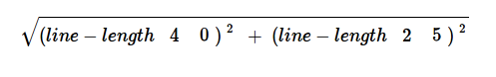

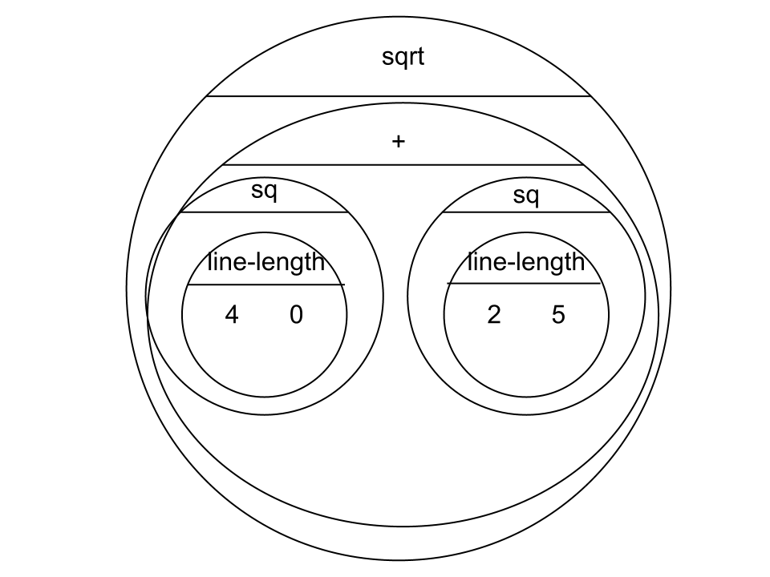

Convert it into Racket code:
(EXAMPLE (_distance __ _4 2 0 5_____________________)

(sqrt (+ (sq (line-length 4 0) ) (sq (line-length 2 5) ) ) )_______________)

Design Recipe: distance
Write a function distance,which takes FOUR inputs:
- px: The x-coordinate of the player
- py: The y-coordinate of the player
- cx: The x-coordinate of another game character
- cy: The y-coordinate of another game character

It should return the distance between the two, using the Distance formula:
Distance = ((line-length px cx)² + (line-length py cy)² )

Contract+Purpose Statement

; ___distance_____ : __number number number number_______ -> ___number___________
name Domain Range

; _______________________________________________________________________________
What does the function do?

Give Examples

(EXAMPLE (_distance 4 2 0 5_________________)

(sqrt (+ (sq (line-length 4 0) ) (sq (line-length 2 5) ) ) )_______________)

(EXAMPLE (____distance 7 8 9 1_______________________)

(sqrt (+ (sq (line-length 7 9) ) (sq (line-length 8 1) ) ) )_______________)

Function Header

(define (__distance___ _px py cx cy__________________)
function name variable names

__(sqrt (+ (sq (line-length px cx) ) (sq (line-length py cy) ) ) )___________)

Design Recipe: collide?

Write a function collide?,which takes FOUR inputs:
- px: The x-coordinate of the player
- py: The y-coordinate of the player
- cx: The x-coordinate of another game character
- cy: The y-coordinate of another game character
It should return true if the coordinates of the player are within 75 pixels of the
coordinates of the other character. Otherwise, false.

Contract+Purpose Statement

; ___collide?___ : ____number number number number__________ -> __boolean______
name Domain Range

; _______________________________________________________________________________
What does the function do?

Give Examples

(EXAMPLE (_collide?___1 3 234 91_____________________)

___(< (distance 1 3 234 91) 75)_____________________________)

(EXAMPLE (__collide?__543 25 24 431_______________)

___(< (distance 543 25 24 431) 75)___________________________)

Function Header

(define (__collide?__ __px py cx cy_________________)

___(< (distance px py cx cy) 75)_________)

TEST | RESULT
(collide?  (world-wumpusX w) 210  50 (world-archerY w)) | (make-world (world-wstatus w)____________________  0____________________  1000____________________  (world-batX w)____________________  (world-arrowX w))____________________)
(collide?  (world-batX w) 440  50 (world-archerY w)) | (make-world (world-wstatus w)____________________  0____________________  (world-wumpusX w)____________________  1500____________________  (world-arrowX w))____________________)
(collide?  (world-wumpusX w) 210  (world-arrowX w)  (+ 25 (world-archerY w))) | (make-world “asleep”____________________  (world-archerY w)____________________  800____________________  (world-batX w)____________________  900)____________________)
(make-world ___________________________________
___________________________________
___________________________________
___________________________________
___________________________________)

Supplemental

The Teacher Game file contains a fully working game up to this

point. As you can see, while the game works it is not fully fleshed

out. Additional code, which could be completed in a couple more

hours of small group work, is implemented in Teacher Game 2.

Changes include the following:

Adding a “Game Over” screen

Implementing the wumpus status: awake/asleep/dead

Writing a second collide function, with decreased range

Providing fine resolution player mvmt

